Finding Different Portfolios
There are thousands of portfolios and ETFs. Where can you start from? Of course, there are many websites, but the two below are the most recommended one. On the first website, you can find many portfolios as well as many advanced capabilities that you are highly recommended to explore. The second website tells you what ETFs you can invest in to replicate a certain portfolio. So, you can select a portfolio from the first website and check the second website to see how to replicate it.
Portfolio Charts – Find a portfolio to love
Lazy Portfolios and ETF composition (lazyportfolioetf.com)

Ray Dalio’s All-Weather Portfolio
It is called “all-weather” because it is designed such that it performs well under all market conditions. Let’s see the steps of choosing this portfolio:
- We check different portfolios on portfoliocharts.com. We choose Ray Dalio’s All-Seasons portfolio.
- We check lazyportfolioetf.com to see how we can replicate the All-Seasons portfolio. Here is what is says:
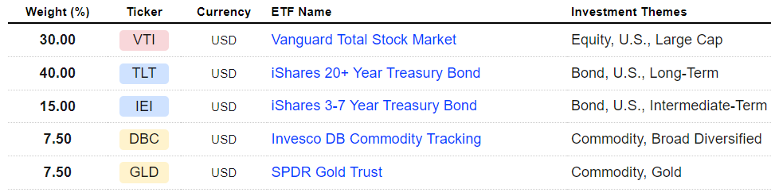
- We check etfdb.com if these ETFs are the cheapest in terms of commission fees or there are cheaper alternatives. So, you take the ETF, search for it on etfdb.com, and check the section at the bottom of the page that tells you “Alternative ETFs in the ETF database…”, you may find ETFs with less commission fees and similar performance. For example, GLD has 0.4% expense ratio, which is expensive. Instead, etfdb.com recommends cheaper ETFs like GLDM and IAU as shown below:
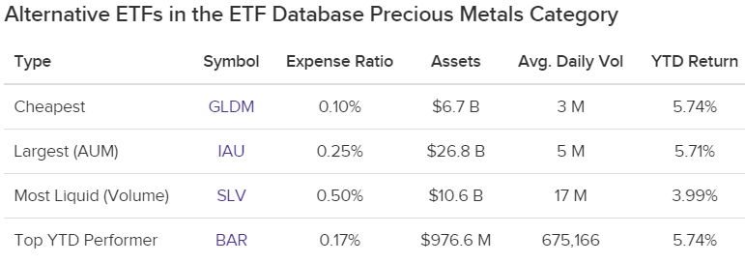
- Once settled on all ETFs, create a portfolio on portfoliovisualizer with these ETFs and with the same percentages in the portfolio selected, and compare this portfolio’s performance with SPY (i.e. S&P500 benchmark).

Let’s compare All-Seasons portfolio to the stock market (with annual rebalancing because this is what the portfolio advises investors to do):
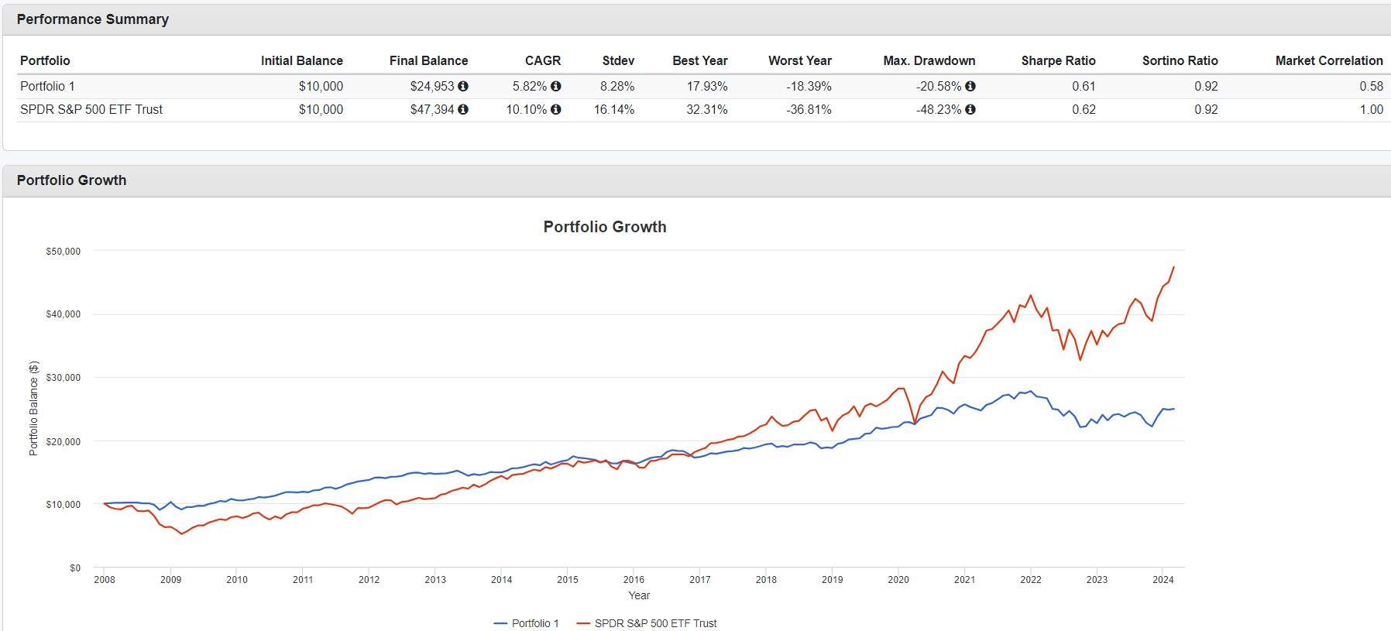
Notes:
- The portfolio has half the returns of the market (5.82% to 10.1%), but also have the risk (8.28% to 16.14%).
- When the market crashed in 2008 and 2020, you can see how the portfolio wasn’t affected. This is why it is called all-seasons portfolio.
- The portfolio’s performance recently deteriorated because its major percentage (40%) is in long-term bonds, and since the interest rates in the US have been increasing in the past few years, the portfolio didn’t perform well. Notice that this wasn’t shown in the course because the above chart stopped at 2021 in the course, so it seemed like this portfolio was perfect before. However, after what we have seen now, should we rethink the “All-Weather” idea of the portfolio? Because it is clear that the portfolio didn’t perform well during rising-interest-rates period. Maybe we can consider it to be our portfolio except that, during periods of rising interest rates, we decrease the percentage of long-term bonds? Search more about this.

Rebalancing, TAA, and Things to Watch Out for
As we said before, for a young passive investor who has a high-risk tolerance, he can just invest in an S&P500 ETF and that’s it. For a young passive investor that has a low/medium-risk tolerance or an old passive investor, the all-weather portfolio is a perfect choice.
So, does this mean that the all-weather portfolio is not suited for active investors? No, it is still possible for an active investor to adapt the all-weather portfolio in certain periods. For example, at the end of the 2020, there was a pandemic, and there were elections in the US. So, there were a lot of uncertainties in the US at that period. An active investor might have decided to adapt the all-weather portfolio until things get clearer. So, the all-weather portfolio is not just for passive investors.

